**Date: 18-04-2025**

**INTERNSHIP LETTER**

This is to certify that **Ms.Kondur Hema** was working in our organization

**Ozrit Ai Solutions** as **React Developer Intern** from **14.02.2025 to 14.04.2025**

We hereby certify that her performance was good during the tenure.

Her contribution to the organization and its success will always be appreciated.

We wish her all the best in her future endeavors.

**For Ozrit Ai Solutions.**

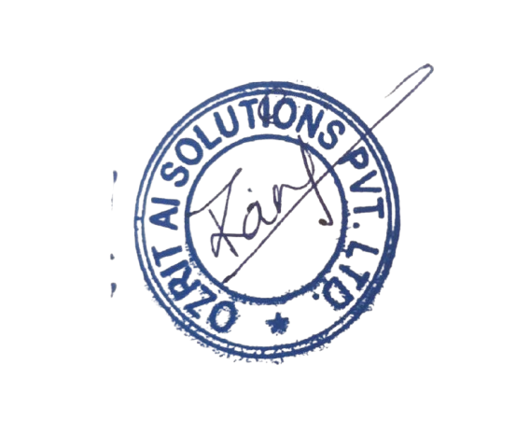

**Rani Kumari**

**HR & Admin Executive**